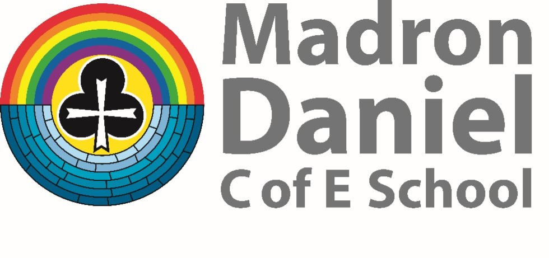

Spiritual, Moral, Social and Cultural Policy

Our Schools’ Vision
‘Rise up, take courage and do it!’
Ezra 10:4
Our Schools’ Values
Hope, Courage and Perseverance

At Madron Daniel C of E Primary School, our understanding of Spirituality considers the areas of : ‘Self’, ‘Others’, ‘World and Beyond.’ The children use the language of In, Out and Up to help them to articulate their spiritual awareness and foster a sense of responsibility, Further details can be found in the Spirituality Policy.

The spiritual development of pupils is shown by their:
- ability to be reflective about their own religious or non-religious worldview
- knowledge of, and respect for, different people’s faiths, feelings and values
- sense of enjoyment and fascination in learning about themselves, others and the world around them
- use of imagination and creativity in their learning
- willingness to reflect on their own experiences, thoughts and feelings
The moral development of pupils is shown by their:
- ability to recognise the difference between right and wrong and to readily apply this
- understanding in their own lives, recognise legal boundaries and, in so doing, respect the civil and criminal law of England
- understanding of the consequences of their behaviour and actions
- interest in investigating and offering reasoned views about moral and ethical issues and ability to understand and appreciate the viewpoints of others on these issues
The social development of pupils is shown by their:
- use of a range of social skills in different contexts, for example working and socialising with other pupils, including those from different religious, ethnic and socio-economic backgrounds
- willingness to participate in a variety of communities and social settings, including by
volunteering, cooperating well with others and being able to resolve conflicts effectively
- acceptance and engagement with the fundamental British values of democracy, the rule of law, individual liberty and mutual respect and tolerance of those with different faiths and beliefs; they develop and demonstrate skills and attitudes that will allow them to participate fully in and contribute positively to life in modern Britain
The cultural development of pupils is shown by their:
- Understanding and appreciation of the wide range of cultural influences that have shaped their own heritage and that of others
- Understanding and appreciation of the range of different cultures in the school and further
afield as an essential element of their preparation for life in modern Britain
- Ability to recognise, and value, the things we share in common across cultural, religious and non-religious, ethnic and socio-economic communities
- Knowledge of Britain’s democratic parliamentary system and its central role in shaping our history and values, and in continuing to develop Britain
- Willingness to participate in and respond positively to artistic, musical, sporting and
cultural opportunities
- Interest in exploring, improving understanding of and showing respect for different faiths and cultural diversity and the extent to which they understand, accept and respect diversity. This is shown by their respect and attitudes towards different religious and non-religious worldviews, and different ethnic and socio-economic groups in the local, national and global communities

Planning
When planning lessons, teachers are aware of the need to plan opportunities to develop a wide variety of spiritual, moral, social and cultural needs. A vast majority delivered through cross curricular activities as well as specific PSHE and RE lessons.

Spiritual Development
Provision | How it is evidenced
- Whole school Values based half-termly themes for Collective Worship  - Collective Worship and Assemblies  - Spirituality Assembly once a half term  - Participation in Truro Diocese Worship Events  - Links to Penlee Cluster and other Churches in the local area  - Class Reflection Areas  - Pop-up prayer space  - Religious Education curriculum  - Opportunities across the curriculum  - Outdoor Education  - Forest School | - Collective Worship plan  - Harvest, Christmas and Easter celebrations  - Whole school Collective Worship, assemblies and celebrations of vision and values  - Special assemblies and celebrations  - Visitor Assemblies and visitors to lessons  - Visiting places of worship  - RE curriculum plans  - Class Curriculum overviews  - Outdoor learning/Forest School  - Residential visits  - Time to reflect upon learning and experiences  - Feedback from stakeholders  - Spirituality Folders

Planned opportunities for spiritual development across the curriculum can be seen across the school. Children are given opportunities to reflect upon the meaning of spiritual experiences.

Examples of experiences commonly regarded as spiritual include:
• Curiosity and questions – answering big questions at the start of every half term
• Awe and wonder
• Connection and belonging
• Heightened awareness of self and others (In and Out)
• Prayer and worship
• Deep feelings of what is felt to be ultimately important
• A sense of security, well-being, worth and purposefulness. The school has developed a climate within which all children can grow and flourish, respect others and be respected; accommodating difference and respecting the integrity of individuals.

Moral Development
Provision | How it is evidenced
- School behaviour Policy  - Religious Education Curriculum  - Collective Worship  - Pupil Voice  - British Values linked to Collective Worship  - PSHE Curriculum  - Taking part in Charitable projects  - Annual Leadership Roles for children  - Half Termly Community Impact Projects linked to Collective Worship | - Regular reviews of behaviour  - Celebration of children's achievements in and out of school  - Pupil Leaders, child participation in a range of pupil groups: School Council, sports, clubs and friendship  - Archbishop’s Young Leaders Award  - Eco council  - E-Safety teaching, Safer Internet Day  - Whole school worship and assemblies and the explicit discussion of half-termly values Weekly certificates to children in assembly and published in school newsletter  - End of year awards for all children  - Charity appeals  - Choir singing in the community  - Intergenerational Project in EYFS  - Photos from Community Impact Projects
We support children to:
- Distinguish right from wrong, based on knowledge of the moral codes of their own
and other cultures
- Develop an ability to think through the consequences of their own and others’ actions
- Have an ability to make responsible and reasoned judgements
- Ensure a commitment to personal values
- Have respect for others’ needs, interests and feelings, as well as their own
- Develop a desire to explore their own and others’ views, and an understanding of the need to review and re-assess their values, codes and principles in the light of experience
Our school develops pupils’ moral development by:
- Providing a clear moral code as a basis for behaviour which is promoted consistently through all aspects of the school. STARS.
- Promoting racial, religious and other forms of equality
- Giving pupils opportunities across the curriculum to explore and develop moral concepts and values – for example, personal rights and responsibilities, truth, justice, equality of opportunity,
- right and wrong, making a conscious effort to make a difference (being courageous advocates)
- Developing an open and safe learning environment in which pupils can express their views and practice moral decision making
- Rewarding expressions of moral insights and good behaviour
- Recognising and respecting the codes and morals of the different cultures represented in the school and wider community
- Encouraging pupils to take responsibility for their actions, for example, respect for property, care of the environment, and developing codes of behaviour
- Providing models of moral virtue through literature, humanities, sciences, arts and assemblies; reinforcing the school’s values through images, posters, classroom displays, etc. and monitoring in simple ways, the success of what is provided
Social Development
Provision | How it is evidenced
- PSHE Curriculum (Kapow)  - Pupil Voice  - Extra-curricular activities  - Outdoor Education  - PE curriculum  - Opportunities created by being part of Truro Diocese | - Pupil Leadership Roles including: School Council, and Eco council  - Residential visits,  - Educational visits  - After school clubs/ Pupil led clubs  - Participation in Music events and concerts  - Transition visits  - Participation in charity support and events  - Participation in sporting events  - Sports Day  - Participation in Truro Diocese events

At Madron Daniel C of E Primary School we recognise that pupils who are becoming socially aware are likely to be developing the ability to:
- Adjust to a range of social contexts by displaying appropriate and sensitive behaviour
- Relate well to other people’s social skills and personal qualities
- Work successfully as a member of a group or team
- Share views and opinions with others
- Resolve conflicts maturely and appropriately
- Reflect on their own contribution to society
- Show respect for people, living things, property and the environment
- Exercise responsibility
- Understand how societies function and are organised in structures such as the family, the
school and wider community
- Understand the notion of interdependence in an increasingly complex society
Our school develops pupil social development by:
- Identifying key values and principles on which school and community life is based
- Fostering a sense of community with common, inclusive values
- Promoting racial, religious and other forms of equality
- Encouraging pupils to work co-operatively
- Encouraging pupils to recognise and respect social differences and similarities
- Providing positive experiences to reinforce our values as a school community – for example ,through assemblies, team building activities, residential experiences, performing arts and sporting events
- Helping pupils develop personal qualities which are valued in a civilised society, for
example, thoughtfulness, honesty, respect for difference, moral principles, independence,
interdependence, self-respect and awareness of others’ needs
- Providing opportunities for engaging in the democratic process and participating in community life
- Providing opportunities for pupils to exercise leadership and responsibility
- Providing positive and effective links with the world of work and the wider community

Cultural Development
Provision | How it is evidenced
- Collective Worship  - RE curriculum  - PSHE curriculum (Kapow)  - School Visits  - Visitors from different faith and social groups  - Arts Curriculum  - Visits from performers, theatre groups and musicians  - World Religion Day  - Interfaith Week  - Links with community groups  - MFL | - Collective Worship Plan links to SMSC and national/international days  - RE teaching and learning  - School visits to churches, museums, galleries concerts, theatre visits  - Meeting authors in person and online  - Dance workshops  - Opportunities to take part in productions at the Minack Theatre  - Music and choir performances  - Musical instrument opportunities  - Visits from people of different cultures  - MFL  - Sports Days

Cultural Development
Children learn about and experience the diversity of other cultures both within modern Britain and
throughout the world. Children who are becoming culturally aware are likely to be developing some or all of the following characteristics:

- An ability to reflect on important questions of meaning and identity
- An interest in exploring the relationship between human beings and the environment

Our school develops cultural development by:
- Extending pupils’ knowledge and use of cultural imagery and language
- Encouraging them to think about special events in life and how they are celebrated
- Recognising and nurturing particular gifts and talents; providing opportunities for pupils to
participate in literature, drama, music, art, crafts and other cultural events and encouraging pupils to reflect on their significance
- Reinforcing the school’s cultural links through displays, posters, workshops etc. As well as
developing partnerships with other schools and individuals to extend pupils’ cultural awareness, for example, theatre, museum and gallery visits

Date of last review:
Headteacher signed: Date:

Chair of Governors signed: Date:

