

**How to keep coronavirus fears from affecting your mental health**

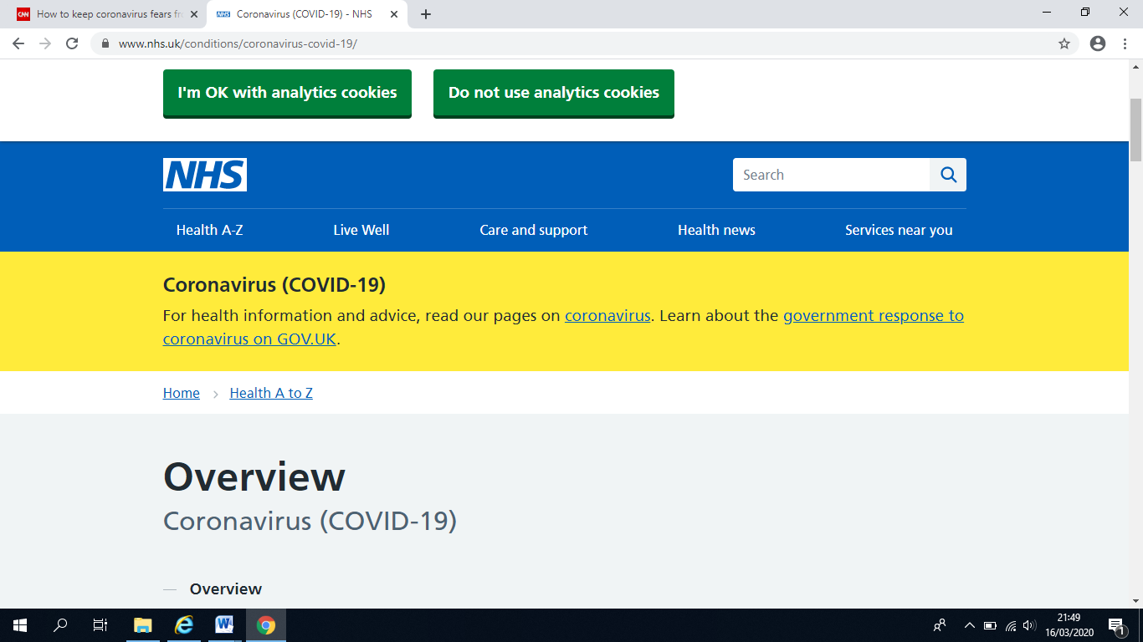

As news about coronavirus (COVID-19) dominate the headlines and public concern is on the rise, Mental Health Europe would like to remind that taking care of your mental health is as important as looking after your physical health. Good mental health and positive wellbeing can help you better cope with the COVID-19 threat and the uncertainty it’s creating.

**There are many ways to keep a sense of control in order to ease coronavirus anxiety**.

**How to avoid catching and spreading Coronavirus (Covid – 19) (Social distancing)**

**Everyone should do what they can to stop Coronavirus spreading**

It is particularly important for people who:

* Are 70 or over
* Have a long-term health condition
* Are pregnant
* Have a weakened immune system

**DO:**

* Wash your hands with soap and water often – do this for at least 20 seconds
* Always wash your hands when you get home or into work
* Use hand sanitiser gel if soap and water are not available
* Cover your mouth and nose with a tissue or your sleeve (not your hands) when you cough or sneeze
* Put used tissues in the bin immediately and wash your hands afterwards
* Avoid close contact with people who have symptoms of coronavirus
* Only travel on public transport if you need to
* Work from home, if you can
* Avoid social activities, such as going to pubs, restaurants, theatres and cinemas
* Avoid events with large groups of people
* Use phone, online services, or apps to contact your GP surgery or other NHS services

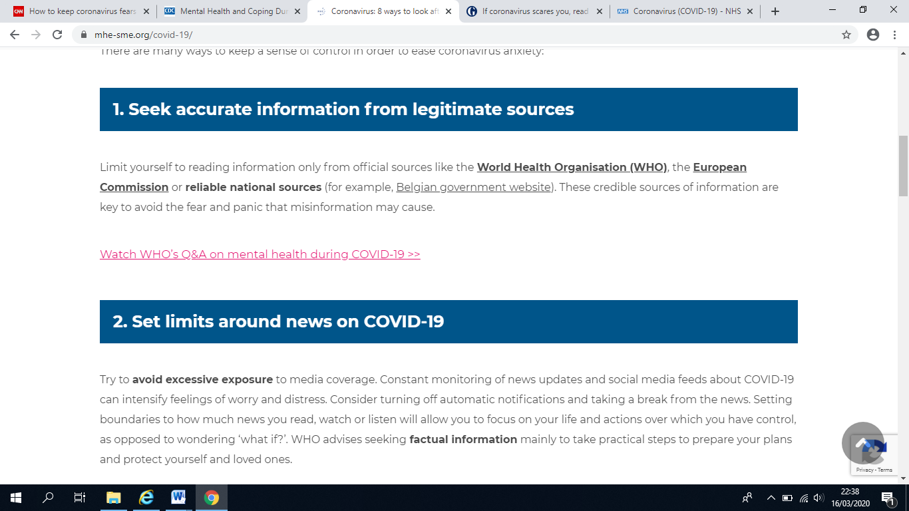

Limit yourself to reading information only from official sources like the [World Health Organisation (WHO)](https://www.who.int/emergencies/diseases/novel-coronavirus-2019), the [European Commission](https://ec.europa.eu/info/live-work-travel-eu/health/coronavirus-response_en) or reliable national sources (for example, [Belgian government website](https://www.info-coronavirus.be/en/)). These credible sources of information are key to avoid the fear and panic that misinformation may cause.

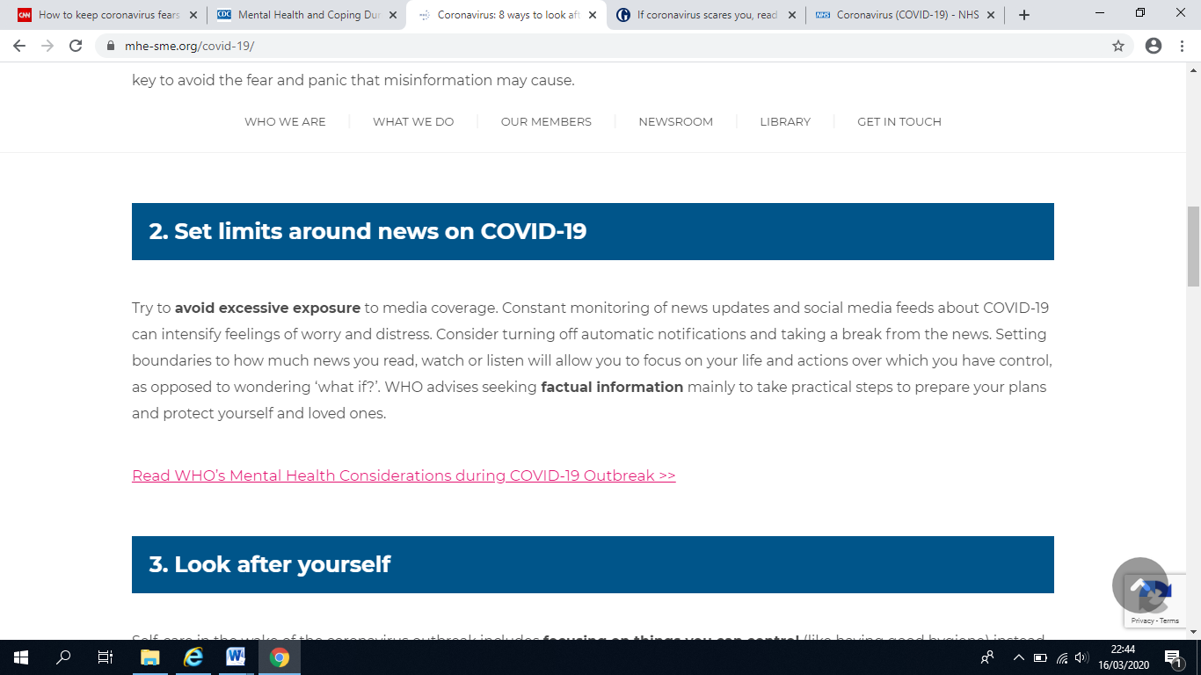

Try to **avoid excessive exposure** to media coverage. Constant monitoring of news updates and social media feeds about COVID-19 can intensify feelings of worry and distress. Consider turning off automatic notifications and taking a break from the news. Setting boundaries to how much news you read, watch or listen will allow you to focus on your life and actions over which you have control, as opposed to wondering ‘what if?’ WHO advises seeking**factual information** mainly to take practical steps to prepare your plans and protect yourself and loved ones.

Use the NHS 111 online Coronavirus service if:

* You feel you cannot cope with your symptoms at home
* Your condition gets worse
* Your symptoms do not get better after 7 days

**https://111.nhs.uk/covid-19**

**Only call 111 if you cannot get help online**

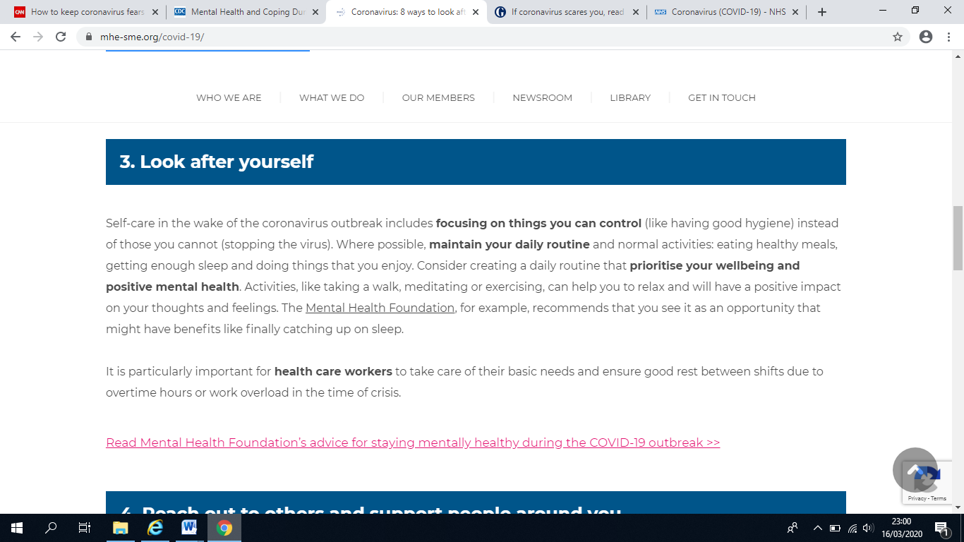

Self-care in the wake of the coronavirus outbreak includes **focusing on things you can control** (like having good hygiene) instead of those you cannot (stopping the virus). Where possible, **maintain your daily routine** and normal activities: eating healthy meals, getting enough sleep and doing things that you enjoy. Consider creating a daily routine that **prioritise your wellbeing and positive mental health**. Activities, like taking a walk, meditating or exercising, can help you to relax and will have a positive impact on your thoughts and feelings. The [Mental Health Foundation](https://mentalhealth.org.uk/), for example, recommends that you see it as an opportunity that might have benefits like finally catching up on sleep.

**Fear and anxiety about a disease can be overwhelming and cause strong emotions in adults and children. Coping with stress will make you, the people you care about, and your community stronger. Here are a few exercises to try in times of stress:**

**The countering technique**

This is a CBT exercise which involves confronting a distressing belief with a rational counter-statement. For example, if your persistent thought is something like “Everyone I love will die from this virus” you can counter it with factual statements such as “Actually, most people who get Covid-19 are likely to make a full recovery, and that’s assuming mum, dad and my little sister will even catch it at all.”

**Breathing and grounding exercises**

From guided yogic breathing, physical movement to using a strong smell (e.g. lavender oil), grounding exercises can help bring you back the here and now. Explore what works for you.

**Allocate yourself a daily ‘worry period’**

Give yourself half an hour to worry about this to your heart’s content, and then go and do something else.

**Treat yourself**

Anything that will give you a little boost can help. It doesn’t need to involve spending money: you can also cook yourself something nice, have a hot bath, or listen to a song you

**Remember that your anxious state isn’t permanent**

When you are in it, anxiety always feels as though it will never end, but it will. It’s hard to remember this at the time, but try your best to keep it in your mind. It is a worrying time, and many of us will have loved ones who might be showing symptoms, but the tendency to jump to the worst-case scenario very rarely reflects reality. Be kind to yourself.

**What is a ‘normal’ response?**

Fear is a normal response to threat, ultimately designed to keep us safe. But when faced with this level of uncertainty about what the future will hold, it can easily spiral out of control, especially if you already experience high levels of anxiety. Fear commonly involves a ‘fight, flight, and freeze’ response- it is normal to experience fatigue, concentration and sleep difficulties.

**What keeps my anxiety going?**

The ‘vicious flower’ model is often used to understand how anxiety is maintained and spirals in anxiety disorders. It helps us understand that what we attend to and what we do can have a considerable impact on our anxiety levels. For example:

